Planning Overview for a Local Study. Year Group: 1
Enquiry Question | What was it like to live in our area 100 years ago?
Aims of your Local Study:  (what will the children achieve?) | - An understanding of what Lydgate looked like 100 years ago and how this compares to what it is like today.  - To be able to use maps to identify similarities and differences in the local area (to be able to identify particular buildings e.g. the school and the previous school site).  - An insight into how the lifestyles of people living in Lydgate has changed (job roles, house roles).  - To ask open questions to find out information from people.
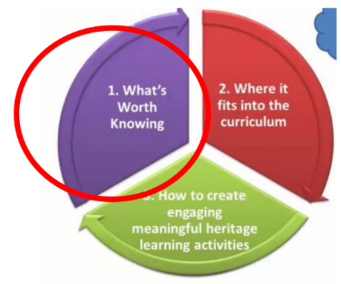  Please give a brief overview of the study, e.g.  - Will it be a map-based study?  - Will you be using Census information (if so, do you have a specific street/ house/ family name)  - Are you focusing on a specific building? Etc. | Initially we will use maps to look at the similarities and differences between Lydgate today and in the past e.g. roads, buildings, houses, our school. We will also use photographs of local buildings from the past and present to identify changes.  A local walk around the area will allow us to see the map observations we made e.g. on our map from the past this road was not here, what was here instead? We will walk to the village hall and discuss how it used to be our school. We will discuss and explore the change of school site and building use. E.g. Who built the original school? What is it used for now? Why did it change location?  It would be beneficial to interview parents/ grandparents who have lived through some of the changes in the local area. They could provide further detail and could inform us of other changes too e.g. changes in lifestyle, job types, roles in the home etc.
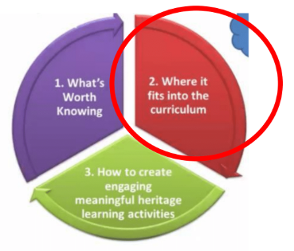  Is this a stand-alone topic or will it be used within a topic to enhance learning? | Links to ‘Changes in Living Memory’ history topic from Autumn 2.  In this topic, we look at the similarities and differences from a range of aspects of life – toys, transport, communication methods etc.  Including a local study within this topic will allow us to look at similarities and differences in terms of streets, buildings, houses, roads, building uses (the change of the school site and the current village hall) and through interviewing parents and grandparents – also an insight into jobs, roles in the house and lifestyle.
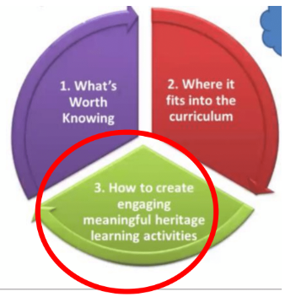  Please list any specific engaging activities you plan to use e.g. a site visit, a walk round the area, high quality old and new images, use of historical directories etc.) | A walk around the local area, included a walk to/ visit inside the village hall which used to be where our school was located.  Images of houses and buildings in the area, both in the past and in the present e.g. the house on the corner of Platting Road – an image from the past and from the present to enhance discussions of changes.  Parents and grandparents who have lived through some of the changes to Lydgate and can come into school/ video call us so we can interview them to find out how Lydgate has changed over the years and also how lifestyles, jobs etc. have changed since they were the children’s age growing up in Lydgate.

