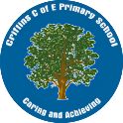
Criftins CE Primary History Scheme
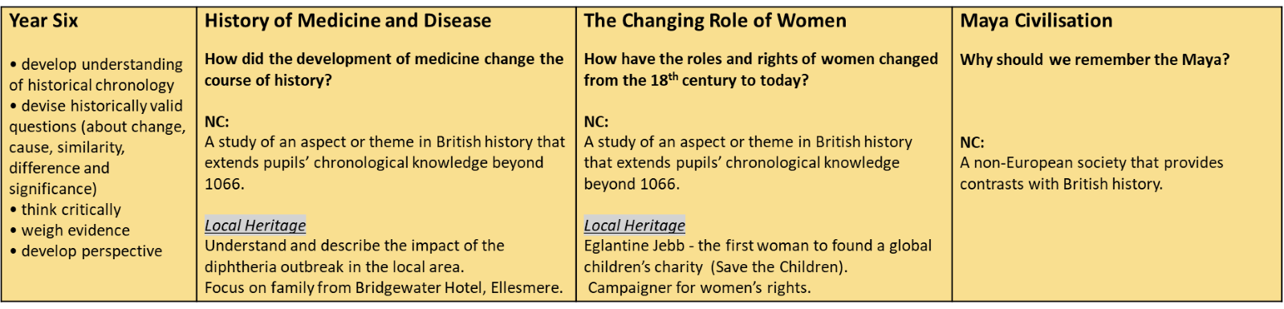
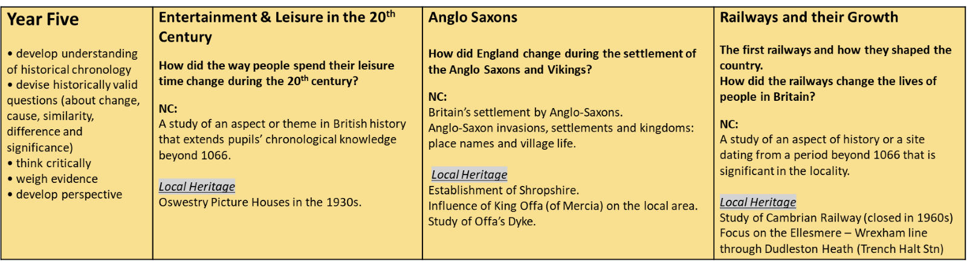
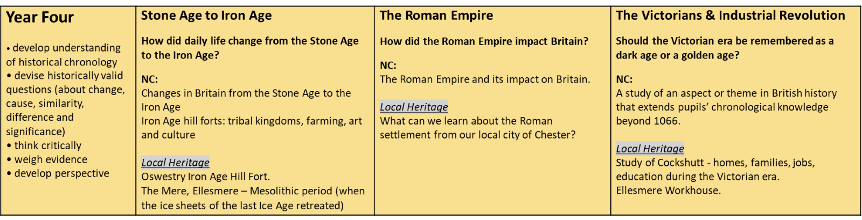
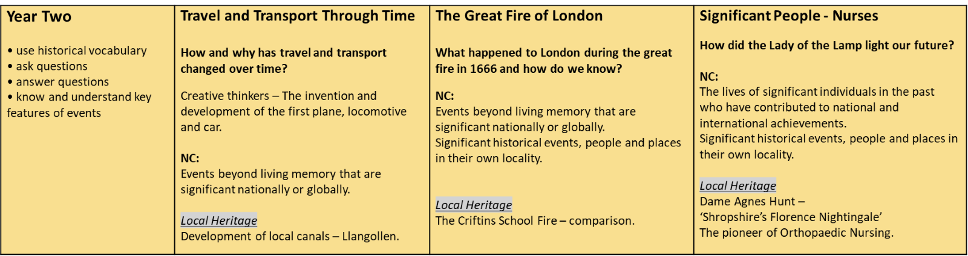
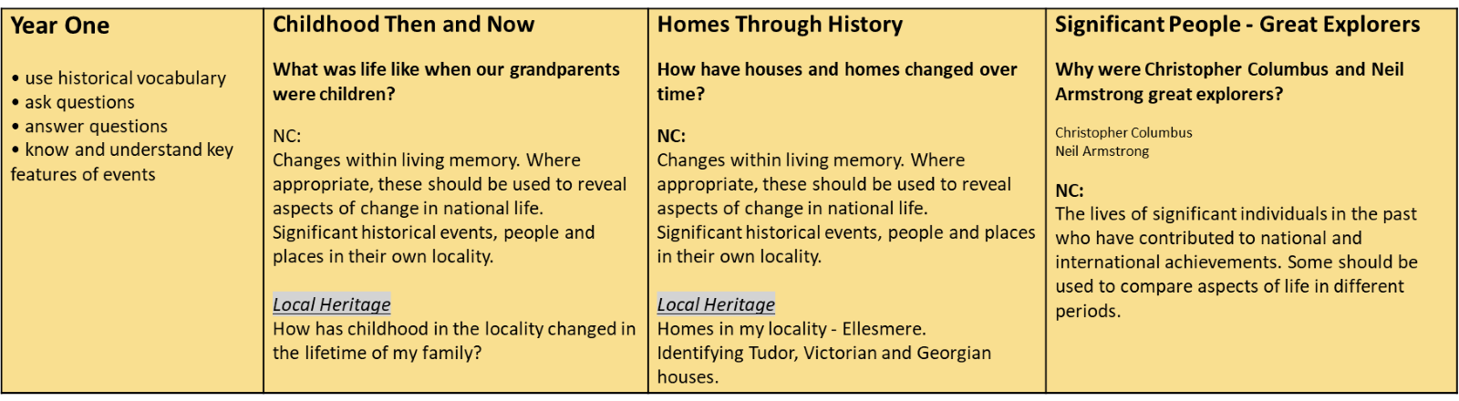
See: https://www.criftins.shropshire.sch.uk/history-curriculum-plan/
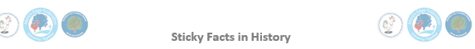
Year 1: Homes through History
People live in different types of homes, but they all have windows, doors and a roof.

Houses from the Tudor, Georgian and Victorian times had different styles.

Victorian homes had no electricity. They used a range for cooking and open fires for heating.

Most Victorian homes didn’t have garages or a driveway because cars weren’t invented.

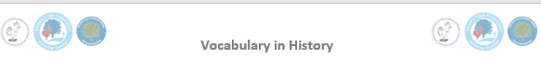
Modern | New or recent.
Detached house | A house that stands alone and is not joined to another house.
Semi-detached house | A house that is joined to another house on one side.
Terraced house | A house in a row of three or more houses joined together.
Bungalow | A house that is all on one level and has no stairs.
Flat | A one-floor home in a large building (with other flats).
Caravan | A large van that be lived in. It can be moved around easily from place to place.
Houseboat | A small boat on a river or canal which people live in.
Tudor | A time when the Tudor family were the kings and queens of England.
Georgian | A time when four kings called George were the kings of England.
Victorian | A time when Queen Victoria was queen of England.
Dolly | Used to move and spin the washing around in the boiling water of a washing tub.
Mangle | Used to squeeze water out of wet clothes.
Washboard | A board used to scrub washing to make it clean.
Range | A Victorian cooker. All of the cooking was done on a range.

SUBSTANTIVE CONCEPTS
Transport | Invasion | Democracy | Entertainment
Religion | Settlement | Home | Legacy
Monarchy | Childhood | Industry | Society

